**SYSTEM MODELS FOR DISTRIBUTED AND CLOUD COMPUTING**

 Distributed and cloud computing systems are built over a large number of autonomous computer nodes. These node machines are interconnected by SANs, LANs, or WANs in a hierarchical manner. With today’s networking technology, a few LAN switches can easily connect hundreds of machines as a working cluster. A WAN can connect many local clusters to form a very large cluster of clusters. In this sense, one can build a massive system with millions of computers connected to edge networks.

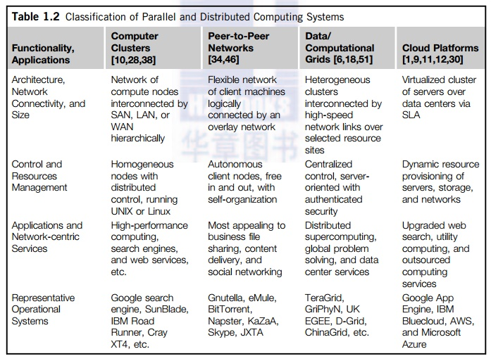

Massive systems are considered highly scalable, and can reach web-scale connectivity, either physically or logically. In Table 1.2, massive systems are classified into four groups: clusters, P2P networks, computing grids, and Internet clouds over huge data centers. In terms of node number, these four system classes may involve hundreds, thousands, or even millions of computers as participating nodes. These machines work collectively, cooperatively, or collaboratively at various levels. The table entries characterize these four system classes in various technical and application aspects.

From the application perspective, clusters are most popular in supercomputing applications. Top 500 supercomputers were built with cluster architecture. It is fair to say that clusters have laid the necessary foundation for building large-scale grids and clouds. P2P networks appeal most to business applications. However, the content industry was reluctant to accept P2P technology for lack of copyright protection in ad hoc networks. Many national grids built in the past decade were underutilized for lack of reliable middleware or well-coded applications. Potential advantages of cloud computing include its low cost and simplicity for both providers and users.

**1. Clusters of Cooperative Computers**

 A computing cluster consists of interconnected stand-alone computers which work cooperatively as a single integrated computing resource. In the past, clustered computer systems have demonstrated impressive results in handling heavy workloads with large data sets.

**1.1 Cluster Architecture**

 Figure 1.15 shows the architecture of a typical server cluster built around a low-latency, high-bandwidth interconnection network. This network can be as simple as a SAN (e.g., Myrinet) or a LAN (e.g., Ethernet). To build a larger cluster with more nodes, the interconnection network can be built with multiple levels of Gigabit Ethernet, Myrinet, or InfiniBand switches. Through hierarchical construction using a SAN, LAN, or WAN, one can build scalable clusters with an increasing number of nodes. The cluster is connected to the Internet via a virtual private network (VPN) gateway. The gateway IP address locates the cluster. The system image of a computer is decided by the way the OS manages the shared cluster resources. Most clusters have loosely coupled node computers. All resources of a server node are managed by their own OS. Thus, most clusters have multiple system images as a result of having many autonomous nodes under different OS control.

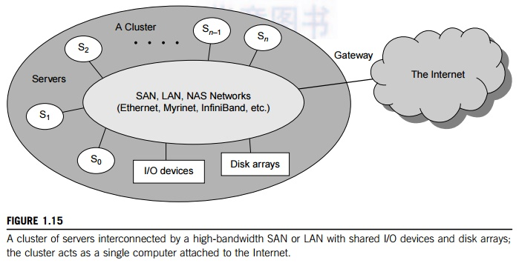

**Major Cluster Design Issues**

Unfortunately, a cluster-wide OS for complete resource sharing is not available yet. Middleware or OS extensions were developed at the user space to achieve SSI at selected functional levels. Without this middleware, cluster nodes cannot work together effectively to achieve cooperative computing. The software environments and applications must rely on the middleware to achieve high performance. The cluster benefits come from scalable performance, efficient message passing, high system availability, seamless fault tolerance, and cluster-wide job management

**2. Grid Computing Infrastructures**

Like an electric utility power grid, a computing grid offers an infrastructure that couples computers, software/middleware, special instruments, and people and sensors together. The grid is often con-structed across LAN, WAN, or Internet backbone networks at a regional, national, or global scale. Enterprises or organizations present grids as integrated computing resources. They can also be viewed as virtual platforms to support virtual organizations. The computers used in a grid are pri-marily workstations, servers, clusters, and supercomputers. Personal computers, laptops, and PDAs can be used as access devices to a grid system.

 Figure 1.16 shows an example computational grid built over multiple resource sites owned by different organizations. The resource sites offer complementary computing resources, including workstations, large servers, a mesh of processors, and Linux clusters to satisfy a chain of computational needs. The grid is built across various IP broadband networks including LANs and WANs already used by enterprises or organizations over the Internet

Grid technology demands new distributed computing models, software/middleware support, network protocols, and hardware infrastructures. National grid projects are followed by industrial grid plat-form development by IBM, Microsoft, Sun, HP, Dell, Cisco, EMC, Platform Computing, and others. New grid service providers (GSPs) and new grid applications have emerged rapidly, similar to the growth of Internet and web services in the past two decades. In Table 1.4, grid systems are classified in essentially two categories: computational or data grids and P2P grids. Computing or data grids are built primarily at the national level.

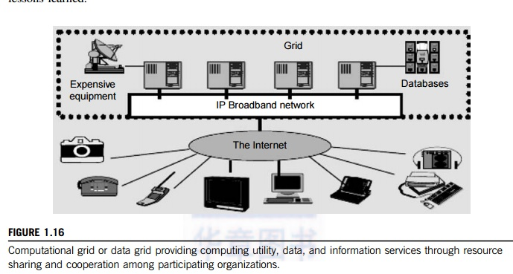

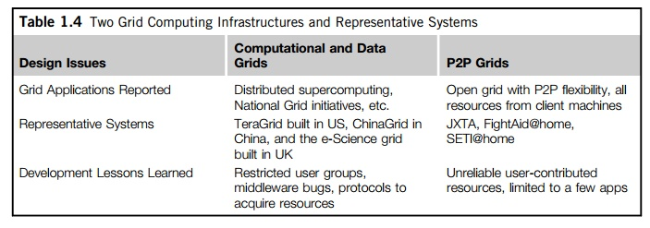

**3. Peer-to-Peer Network Families**

An example of a well-established distributed system is the client-server architecture. In this sce-nario, client machines (PCs and workstations) are connected to a central server for compute, e-mail, file access, and database applications. The P2P architecture offers a distributed model of networked systems. First, a P2P network is client-oriented instead of server-oriented

In a P2P system, every node acts as both a client and a server, providing part of the system resources. Peer machines are simply client computers connected to the Internet. All client machines act autonomously to join or leave the system freely. This implies that no master-slave relationship exists among the peers. No central coordination or central database is needed. In other words, no peer machine has a global view of the entire P2P system. The system is self-organizing with distributed control.

**4. Cloud Computing over the Internet**

“A cloud is a pool of virtualized computer resources. A cloud can host a variety of different workloads, including batch-style backend jobs and interactive and user-facing applications.” Based on this definition, a cloud allows workloads to be deployed and scaled out quickly through rapid provisioning of virtual or physical machines. The cloud supports redundant, self-recovering, highly scalable programming models that allow workloads to recover from many unavoidable hardware/software failures. Finally, the cloud system should be able to monitor resource use in real time to enable rebalancing of allocations when needed.